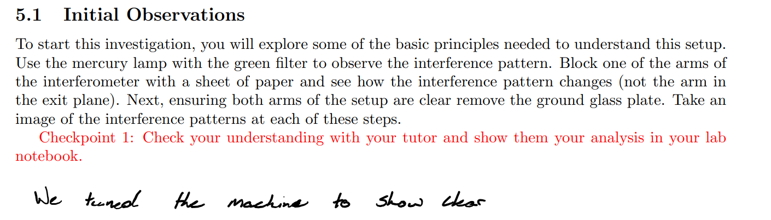

Peaks of interference

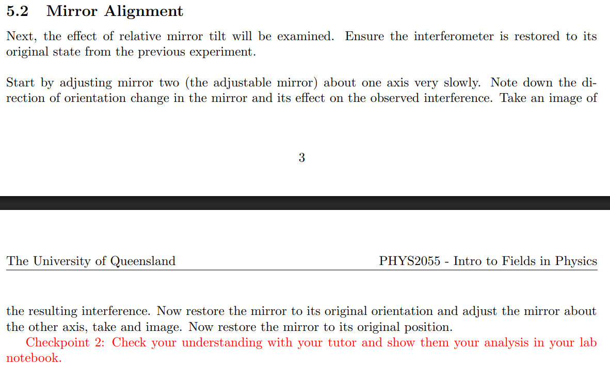

Ink Drawings
Ink Drawings
Ink Drawings
Ink Drawings
Ink Drawings
Ink Drawings
Ink Drawings
Ink Drawings
Ink Drawings
Ink Drawings
Ink Drawings
Ink Drawings
Ink Drawings
Ink Drawings
Ink Drawings
Ink Drawings
Ink Drawings
Ink Drawings
Ink Drawings
Ink Drawings
Ink Drawings
Ink Drawings
Ink Drawings
Ink Drawings
Ink Drawings
Ink Drawings
Ink Drawings
Ink Drawings
Ink Drawings
Ink Drawings
Ink Drawings
Ink Drawings
Ink Drawings
Ink Drawings
Ink Drawings
Ink Drawings
Ink Drawings
Ink Drawings
Ink Drawings
Ink Drawings
Ink Drawings
Ink Drawings
Ink Drawings
Ink Drawings
Ink Drawings
Ink Drawings
Ink Drawings
Ink Drawings
Ink Drawings
Ink Drawings
Ink Drawings
Ink Drawings
Ink Drawings
Ink Drawings
Ink Drawings
Ink Drawings
Ink Drawings
Ink Drawings
Ink Drawings
Ink Drawings
Ink Drawings
Ink Drawings
Ink Drawings
Ink Drawings
Ink Drawings
Ink Drawings
Ink Drawings
Ink Drawings
Ink Drawings
Ink Drawings
Ink Drawings
Ink Drawings
Ink Drawings
Ink Drawings
Ink Drawings
Ink Drawings
Ink Drawings
Ink Drawings
Ink Drawings
Ink Drawings
Ink Drawings
Ink Drawings
Ink Drawings
Ink Drawings
Ink Drawings
Ink Drawings
Ink Drawings
Ink Drawings
Ink Drawings
Ink Drawings
Ink Drawings
Ink Drawings
Ink Drawings
Ink Drawings
Ink Drawings
Ink Drawings
Ink Drawings
Ink Drawings
Ink Drawings
Ink Drawings
Ink Drawings
Ink Drawings
Ink Drawings
Ink Drawings
Ink Drawings
Ink Drawings
Ink Drawings
Ink Drawings
Ink Drawings
Ink Drawings
Ink Drawings
Ink Drawings
Ink Drawings
Ink Drawings
Ink Drawings
Ink Drawings
Ink Drawings
Ink Drawings
Ink Drawings
Ink Drawings
Ink Drawings
Ink Drawings
Ink Drawings
Ink Drawings
Ink Drawings
Ink Drawings
Ink Drawings
Ink Drawings
Ink Drawings
Ink Drawings
Ink Drawings
Ink Drawings
Ink Drawings
Ink Drawings
Ink Drawings
Ink Drawings
Ink Drawings
Ink Drawings
Ink Drawings
Ink Drawings
Ink Drawings
Ink Drawings
Ink Drawings
Ink Drawings
Ink Drawings
Ink Drawings
Ink Drawings
Ink Drawings
Ink Drawings
Ink Drawings
Ink Drawings
Ink Drawings
Ink Drawings
Ink Drawings
Ink Drawings
Ink Drawings
Ink Drawings
Ink Drawings
Ink Drawings
Ink Drawings
Ink Drawings
Ink Drawings
Ink Drawings
Ink Drawings
Ink Drawings
Ink Drawings
Ink Drawings
Ink Drawings


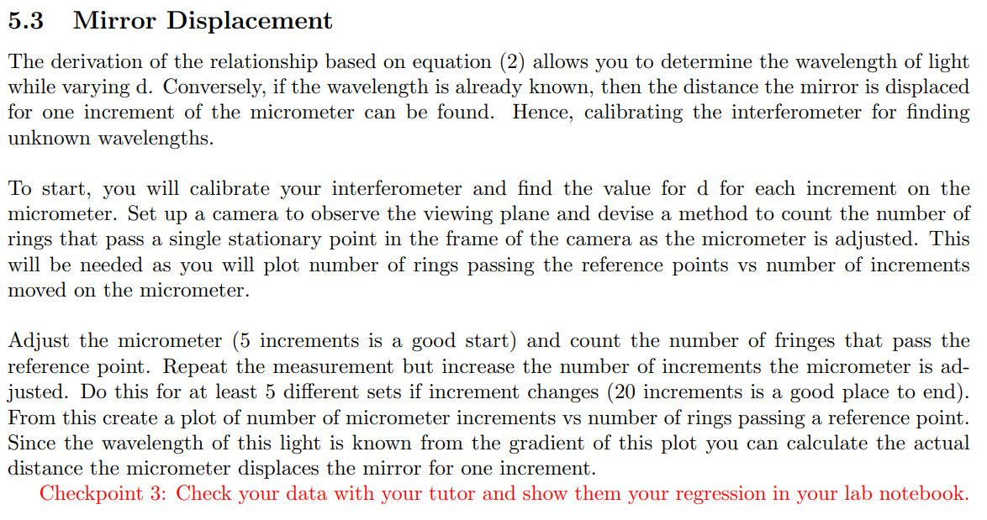

Ink Drawings
Ink Drawings
Ink Drawings
Ink Drawings
Ink Drawings
Ink Drawings
Ink Drawings
Ink Drawings
Ink Drawings
Ink Drawings
Ink Drawings
Ink Drawings
Ink Drawings
Ink Drawings
Ink Drawings
Ink Drawings
Ink Drawings
Ink Drawings
Ink Drawings
Ink Drawings
Ink Drawings
Ink Drawings
Ink Drawings
Ink Drawings
Ink Drawings
Ink Drawings
Ink Drawings
Ink Drawings
Ink Drawings
Ink Drawings
Ink Drawings
Ink Drawings
Ink Drawings
Ink Drawings
Ink Drawings
Ink Drawings
Ink Drawings
Ink Drawings
Ink Drawings
Ink Drawings
Ink Drawings
Ink Drawings
Ink Drawings
Ink Drawings
Ink Drawings
Ink Drawings
Ink Drawings
Ink Drawings
Ink Drawings
Ink Drawings
Ink Drawings
Ink Drawings
Ink Drawings
Ink Drawings
Ink Drawings
Ink Drawings
Ink Drawings
Ink Drawings
Ink Drawings
Ink Drawings
Ink Drawings
Ink Drawings
Ink Drawings
Ink Drawings
Ink Drawings
Ink Drawings
Ink Drawings
Ink Drawings
Ink Drawings
Ink Drawings
Ink Drawings
Ink Drawings
Ink Drawings
Ink Drawings
Ink Drawings
Ink Drawings
Ink Drawings
Ink Drawings
Ink Drawings
Ink Drawings
Ink Drawings
Ink Drawings
Ink Drawings
Ink Drawings
Ink Drawings
Ink Drawings
Ink Drawings
Ink Drawings
Ink Drawings
Ink Drawings
Ink Drawings
Ink Drawings
Ink Drawings
Ink Drawings
Ink Drawings
Ink Drawings
Ink Drawings
Ink Drawings
Ink Drawings
Ink Drawings
Ink Drawings
Ink Drawings
Ink Drawings
Ink Drawings
Ink Drawings
Ink Drawings
Ink Drawings
Ink Drawings
Ink Drawings
Ink Drawings
Ink Drawings
Ink Drawings
Ink Drawings
Ink Drawings
Ink Drawings
Ink Drawings
Ink Drawings
Ink Drawings
Ink Drawings
Ink Drawings
Ink Drawings
Ink Drawings
Ink Drawings
Ink Drawings
Ink Drawings
Ink Drawings
Ink Drawings
Ink Drawings
Ink Drawings
Ink Drawings
Ink Drawings
Ink Drawings
Ink Drawings
Ink Drawings
Ink Drawings
Ink Drawings
Ink Drawings
Ink Drawings
Ink Drawings
Ink Drawings
Ink Drawings
Ink Drawings
Ink Drawings
Ink Drawings
Ink Drawings
Ink Drawings
Ink Drawings
Ink Drawings
Ink Drawings
Ink Drawings
Ink Drawings
Ink Drawings
Ink Drawings
Ink Drawings
Ink Drawings
Ink Drawings
Ink Drawings
Ink Drawings
Ink Drawings
Ink Drawings
Ink Drawings
Ink Drawings
Ink Drawings
Ink Drawings
Ink Drawings
Ink Drawings
Ink Drawings
Ink Drawings
Ink Drawings
Ink Drawings
Ink Drawings
Ink Drawings
Ink Drawings
Ink Drawings
Ink Drawings
Ink Drawings
Ink Drawings
Ink Drawings
Ink Drawings
Ink Drawings
Ink Drawings
Ink Drawings
Ink Drawings
Ink Drawings
Ink Drawings
Ink Drawings
Ink Drawings
Ink Drawings
Ink Drawings
Ink Drawings
Ink Drawings
Ink Drawings
Ink Drawings
Ink Drawings
Ink Drawings
Ink Drawings
Ink Drawings
Ink Drawings
Ink Drawings
Ink Drawings
Ink Drawings
Ink Drawings
Ink Drawings
Ink Drawings
Ink Drawings
Ink Drawings
Ink Drawings
Ink Drawings
Ink Drawings
Ink Drawings
Ink Drawings
Ink Drawings
Ink Drawings
Ink Drawings
Ink Drawings
Ink Drawings
Ink Drawings
Ink Drawings
Ink Drawings
Ink Drawings
Ink Drawings
Ink Drawings
Ink Drawings
Ink Drawings
Ink Drawings
Ink Drawings
Ink Drawings
Ink Drawings
Ink Drawings
Ink Drawings
Ink Drawings
Ink Drawings
Ink Drawings
Ink Drawings
Ink Drawings
Ink Drawings
Ink Drawings
Ink Drawings
Ink Drawings
Ink Drawings
Ink Drawings
Ink Drawings
Ink Drawings
Ink Drawings
Ink Drawings


Ink Drawings
Ink Drawings
Ink Drawings
Ink Drawings
Ink Drawings
Ink Drawings
Ink Drawings
Ink Drawings
Ink Drawings
Ink Drawings
Ink Drawings
Ink Drawings
Ink Drawings
Ink Drawings
Ink Drawings
Ink Drawings
Ink Drawings
Ink Drawings
Ink Drawings
Ink Drawings
Ink Drawings
Ink Drawings
Ink Drawings
Ink Drawings
Ink Drawings
Ink Drawings
Ink Drawings
Ink Drawings
Ink Drawings
Ink Drawings
Ink Drawings
Ink Drawings
Ink Drawings
Ink Drawings
Ink Drawings
Ink Drawings


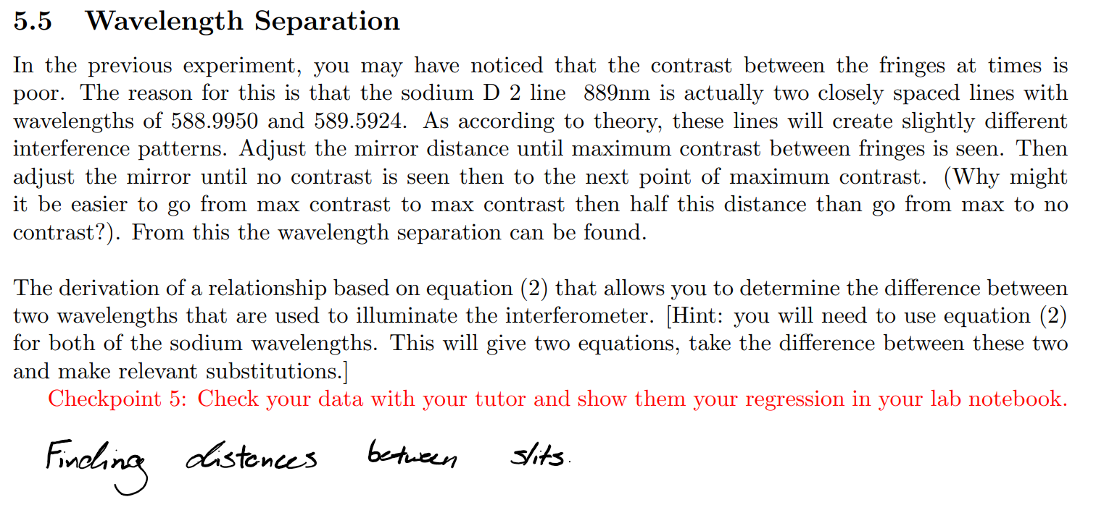

Find the distance between minima and maxima of interference discernability. Super position of the equation above and by approximating the two wavelengths as equal, delta lambda can be found using the wavelength of sodium calculated above.